2022-2023 MFA in Screenwriting
Read all instructions carefully before completing the application.
Instructions for Brazilian Applicants to the MFA Program.

Please read all instructions carefully and follow the application guidelines below. Brazilian candidates must submit the application through the Slate online application system for the MFA Program by the deadline, July 09, 2021.

GENERAL INFORMATION 3
CREATING YOUR ONLINE ACCOUNT 3
MANAGING YOUR APPLICATION 4
WELCOME 4
PRELIMINARY QUESTIONS 4
IIE DATA PRIVACY CONSENT FOR APPLICANTS IN IIE-MANAGED PROGRAMS* 4
Reference Materials Waiver* 4
COUNTRY INFORMATION 4
PERSONAL INFORMATION 5
CONTACT INFORMATION 5
ACADEMIC & PROFESSIONAL INFORMATION 5
CURRICULUM VITAE/ RESUME 5
ACADEMIC BACKGROUND 5
PROFESSIONAL EXPERIENCE 6
AWARDS AND RECOGNITIONS 6
EXPERIENCE ABROAD 6
ACADEMIC MATERIALS 6
LANGUAGE SKILLS 6
ADDITIONAL LANGUAGE SKILLS 6
TEST SCORES 6
PLAGIARISM AGREEMENT 6
STUDY PLAN 6
INTENDED GRANT PERIOD 7
STUDY OBJECTIVE 7
PERSONAL STATEMENT 7
WRITING SAMPLE 7
GRANT AND TRAVEL PLANS 7
EXPECTED ADDITIONAL FUNDING 7
PASSPORT/TRAVEL DOCUMENT AND DEPENDENTS 7
ADDITIONAL INFORMATION 8
RECOMMENDATIONS 8
SIGNATURE 8
REVIEW 8
MANAGING YOUR APPLICATION 9
PRELIMINARY QUESTIONS 9
COUNTRY INFORMATION 10
DATA PRIVACY 10
PERSONAL INFORMATION 10
CONTACT INFORMATION 10
ACADEMIC & PROFESSIONAL INFORMATION 10
Curriculum Vitae/Resume 11
Academic Background 11
Current Professional Profile 11
Awards and Recognitions 11
Experience Abroad 11
ACADEMIC MATERIALS 11
LANGUAGE SKILLS 11
English Language Proficiency 11
Additional Language Skills 11
TEST SCORES 12
STUDY PLAN 12
Intended Grant Period 12
Study/Research Objective 12
Personal Statement 12
Proposed U.S. Institution 12
Applied U.S. Institutions 12
GRANT AND TRAVEL PLANS 12
Expected Additional Funding 12
Passport/Travel Document and Dependents 13
ADDITIONAL INFORMATION 13
RECOMMENDATIONS 13
SIGNATURE 13
REVIEW 14
CREATIVE PACKAGE AND VIDEO 14
MFA APPLICATION CHECKLIST 14

APPLICATION STEPS

GENERAL INFORMATION
- The application is supported by all modern browsers. We highly recommend that you use a current version of Google Chrome, which supports Windows, Mac, and Linux platforms.

Prior to starting an application, please complete the following steps:
- STEP 1: Learn requirements for submitting an application
Before you begin an application, you must make sure you are eligible to apply https://fulbright.org.br/bolsas-para-brasileiros/mestrado-em-roteiro-de-cinema-nos-eua-master-of-fine-arts-mfa/
- STEP 2: Record username and password in a safe place
Your email address is your username. When you create an account for this online application, record your password in a secure place. You can log in and out of the application as frequently as you like using your username and password. If necessary, you can reset your password by clicking the “Forgot Your Password” link on the log-in page.
- STEP 3: Complete the application
- You do not need to complete this application at one time. You can re-enter at any time to edit your application. However, once you SUBMIT your application, you CANNOT make changes to it.
- Use upper and lower-case letters (e.g. John Smith). Avoid using all capital letters (e.g. JOHN SMITH). Do not use special characters, such as accent marks.
- You can copy and paste information into all text boxes.
- Limit your responses to the space provided in all text boxes.
- Prepare required documents and save them in PDF format. It is highly recommended that to preserve any formatting and special characters in your documents, you upload them in PDF format.
- Some questions are “required.” They are marked with an asterisk (*). You will not be able to submit your application until all required items are complete.
- STEP 4: Submit the application
Once you have entered all required information, including recommenders, review your application for errors. If all information is correct, submit your application. Once you submit you CANNOT make changes to your application.

CREATING YOUR ONLINE ACCOUNT
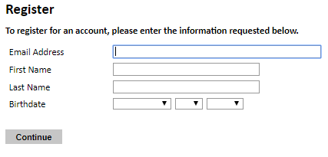
- Enter your email address, first name, last name, and select your date of birth (Month-Date-Year) from the drop-down menus. Your name must be entered exactly the way it appears (or will appear) on your passport.
Note: Use an email address that you will be able to access for at least two years after submitting your application. This is the email address you will use to log in to your application account. We recommend you do NOT use a work email address if you will not have access to it during your grant in the U.S.
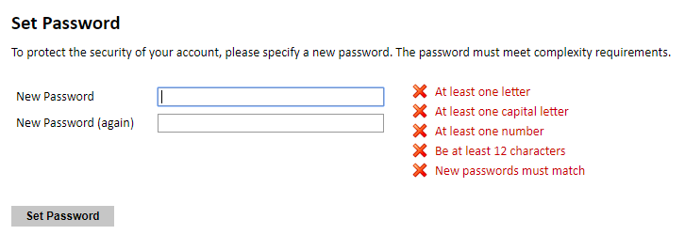
- You will receive an email from apply@iie.org confirming that you have started the application. The email will include a temporary PIN. Follow the instructions in the email to activate your account using the temporary PIN.

- You will be prompted to enter your pin and then create a password to complete login.
- Returning users: Click Log in and enter your email address and password. If you do not remember your password, click Forgot your password? and follow the resulting instructions.

MANAGING YOUR APPLICATION
EDITING YOUR APPLICATION PRIOR TO SUBMISSION
- You may log in at any time to review and edit your application form, upload documents, and enter recommender information.
- Remember to save your application after completing each page by pressing the Continue button at the bottom of each page.
Note: The application will automatically log you out after 60 minutes of inactivity, so it is best to save your application frequently.
REVIEWING YOUR APPLICATION AFTER SUBMISSION
- After you SUBMIT your application, you CANNOT make any changes.
- You may continue to log in to your account to view the information you have submitted, save a PDF of your application form, and manage your recommenders.
- You can manage your recommenders by clicking on the Recommendations section of the online application.

LETTERS OF RECOMMENDATION
- Letters of recommendation will be submitted directly to Fulbright by the recommenders you registered via your application.
- Letters of recommendation can be submitted by your recommenders during your application process or after you submit the application.
- If your recommender is unavailable, you will have the option to exclude the recommender and add an alternative after you submit the application.

WELCOME
I have reviewed the Fulbright policy guidelines, particularly the grounds for Revocation, Termination and Suspension of Grant. Select Yes

PRELIMINARY QUESTIONS
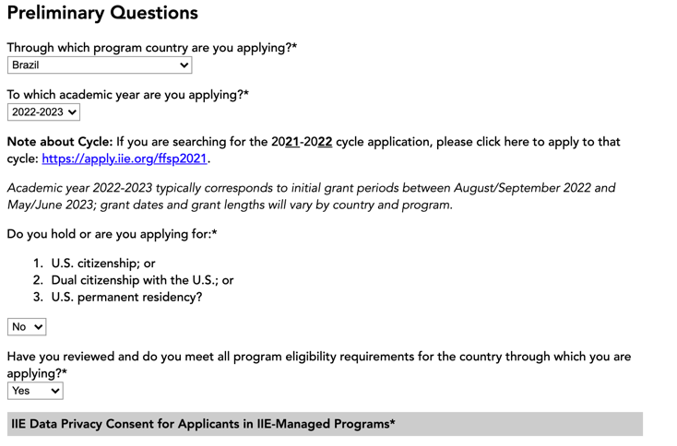
- These questions address essential MFA program eligibility. All questions are required.
- Select BRAZIL, the country through which you are applying for the MFA Program.
- Select the appropriate program year from the dropdown menu, which is 2022-2023
- U.S. Citizenship, Dual Citizenship with the U.S. or Permanent Residency: select ‘yes’ or ‘no’ to indicate your response. Applicants cannot be U.S. citizens or permanent residents of the U.S. to participate in the Master of Fine Arts in Screenwriting.
- Select ‘yes’, ‘no’, or ‘unsure’ to indicate if you are aware and meet all program eligibility requirements.
- Please review the program eligibility requirements for Brazilian candidates before proceeding.

IIE DATA PRIVACY CONSENT FOR APPLICANTS IN IIE-MANAGED PROGRAMS*
Select Yes

Reference Materials Waiver*
Select Yes

By selecting yes, it will allow you to fill the information regarding your recommenders.

COUNTRY INFORMATION
- Review all information in this section!
- Note any country-specific and award-specific instructions for completing the rest of the application, including:
Fulbright Brazil website: https://fulbright.org.br
Deadline information: July 09, 2021.
Award Information
- Current Award: * Master of Fine Arts in Screenwriting

PERSONAL INFORMATION
- Enter all required biographical information.
- Enter your name exactly as it appears on your passport. Only enter a preferred name if it is DIFFERENT than your legal name (e.g. Alex instead of Alexander).
- If your name is recorded differently on any previous records, list it in the Name on Previous Records section (e.g. maiden name).
- Enter your city of birth and select country of birth, sex (as it appears or will appear on your passport or travel document), preferred gender identity, and marital status from the dropdown menus provided. Enter a number of dependents.
- Select your country of citizenship and country of residence from the dropdown menus provided.
- Enter your national identification number (CPG or RG) and any additional countries in which you hold citizenship.
- To select multiple countries, hold down the CTRL (PC) or Command (Mac) button when selecting options.

CONTACT INFORMATION
- Enter all required contact information. Please review country-specific guidance to determine whether you must provide additional information.
- Select the country where you live from the dropdown list first when entering your permanent address (i.e. physical address where you live). Remember, if you do not live in Brazil you are not eligible for this grant.
- Do not use accents or special characters.
Note: All system-generated emails will continue to go to your primary email address.
- Entering emergency contact information is not required unless directed by the country-specific instructions. If you would like to provide emergency contacts in your home country, please enter the appropriate information.

ACADEMIC & PROFESSIONAL INFORMATION
- This section collects information about your academic and professional background, including your curriculum vitae/resumé, academic degrees, professional experience, awards and recognitions, and experience abroad.

CURRICULUM VITAE/ RESUME
In one single PDF, upload your curriculum vitae/resumé in PDF format that does not exceed four (4) pages (in English). Include education; work experience and internships; honors and awards; and publications or creative works.

Note: If your file exceeds 4 pages, an error message will appear on the Review page and will prevent submission of your application. You may only provide one Curriculum Vitae/Resumé.
Required document.

ACADEMIC BACKGROUND
- List your undergraduate educational institutions from which you have received a degree. You MUST include any education institutions you are currently attending (even if you have not yet completed your educational program) and estimated date of graduation/completion.

PROFESSIONAL EXPERIENCE
- List your current professional affiliation or employer by clicking Add Experience under Position Title: Choose the role which most closely corresponds to your current role from the dropdown.

AWARDS AND RECOGNITIONS
- List up to four professional memberships in cultural, educational, and professional organizations. If you do not have anything to add, leave text boxes blank.

EXPERIENCE ABROAD
- List any travel, study or residency you have had abroad (in any country other than your own) for more than one month. This can include time overseas for education, research, business, vacation, etc.
- Select ‘yes’ or ‘no’ to indicate if you have previously entered the United States on a J-1 or J-2 visa. If ‘yes’, you are required to select the J category of sponsorship from the list and upload a copy of your previous DS-2019.

ACADEMIC MATERIALS
- This section collects copies of your unofficial transcripts and/or diplomas.
Please upload an Official copy of your bachelor’s degree transcript (histórico escolar e diploma) from your bachelor’s degree granting institution. At this point the documents can be in Portuguese. Required documents.

LANGUAGE SKILLS
- This section collects information about your native language, English language skills, and any additional languages that are relevant to your project proposal.

ADDITIONAL LANGUAGE SKILLS
- Select the number of additional languages that you would like to include that may be of use for your project or study plans.
- If your native language is not English, a section collecting your English language proficiency will appear.
Rate your English language proficiency in Reading, Writing, and Speaking. Select Native, Advanced, Intermediate, Beginner or No Ability from the dropdown menus as appropriate.

TEST SCORES
- This section collects information about standardized test scores that you have taken or will take in the future. When you enter test scores, you must upload your Score Report at the Additional Information section.

PLAGIARISM AGREEMENT
- Plagiarism in any part of your application will result in your disqualification from participating in the Fulbright Program.

STUDY PLAN
- This section collects information about your proposed plan of study in the U.S.
- Select the degree objective to which you are applying: Master’s
- Select the most appropriate major academic discipline and primary specialization from the dropdown menus: Film/ Cinema Studies
- Enter a brief description of the field in which you plan to specialize in the U.S. Once you select your field of study from the drop down, you will use the look-up table to find your specialization. This is a fairly comprehensive list, so please select the one that is most appropriate. You can expand on this in your Study Objective essay. Essays are as a method for measuring critical thinking skills, understanding and writing skills. The essays will allow you to emphasize key qualifications, areas of expertise, skills and/or goals; and also, to provide an opportunity for you to communicate your understanding of the program’s goals and why you would be an appropriate candidate.

INTENDED GRANT PERIOD
- Enter your proposed length of stay in the U.S. and select your proposed date of arrival in the U.S. (Month-Day-Year format). Starting in August or September 2022 and Ending in April, May or June 2024 (21 months).

STUDY OBJECTIVE
- In English – you must send a study objective with no more than one page. Write a clear and detailed description of your study/research objectives, and give your reasons for wanting to pursue them․ Be specific about your major field and your specialized interests within this field․ Describe the kind of program you expect to undertake, and explain how your study plan fits in with your previous training and your future objectives․ This statement is an essential part of your application and is required․ Do not mention specific U․S․ universities at which you would like to study․ It is strongly recommended that you upload in PDF format. Required document.

PERSONAL STATEMENT
- Upload a copy of your personal statement in English. This personal statement should be a narrative statement describing how you have achieved your current goals․ It should not be a mere listing of facts․ It should include information about your education, practical experience, special interests, and career plans․ Describe any significant factors that have influenced your educational or professional development․ Comment on the number of years of practical experience already completed in the field in which academic work will be done in the U․S․ Do not mention specific U․S․ universities at which you would like to study․ It is strongly recommended that you upload in PDF format.
ONLY ONE PAGE. Required document.

WRITING SAMPLE
Skip this section.

UNIVERSITY PREFERENCES
- You should provide up to 3 university preferences with as much information as possible. Most MFA programs, especially top-ranked ones, are extremely competitive and have rigorous and detailed application requirements. If you’re selected to the program, you must meet the requirements of the institutions, which you have been selected for. Note, that due to the length of the Program, the MFA in screenwriting from Columbia University is not eligible.

APPLIED U.S. INSTITUTIONS
- Select ‘yes’ or ‘no’ to indicate if you have applied to any U.S. institutions.

AUTHORIZATION OF RELEASE OF INFORMATION
By your signature you authorize the Fulbright Program Office and/or its administrative agency to access, review, receive and request additional information.

GRANT AND TRAVEL PLANS
- This section gathers information on your personal finances, additional funding you may have applied for/received, passport, and accompanying dependents.

EXPECTED ADDITIONAL FUNDING
- List all non-Fulbright funding you expect to receive during your grant. Not Mandatory.

PASSPORT/TRAVEL DOCUMENT AND DEPENDENTS
- Upload a copy of your passport or another Brazilian official ID (Driver’s license or CNH). If you intend to bring dependents to the U.S., select the number of dependents you intend to have accompany you the U.S. (select 0 if you do not have dependents or your dependents will not accompany you to the U.S.). Required document.

ADDITIONAL INFORMATION
USE THE SECTION COUNTRY-SPECIFIC MATERIALS TO UPLOAD THE COPY OF YOUR:
- TOEFL or IELTS Score Report, taken no earlier than June 1, 2020 (102 TOEFL iBT, or 7.0 IELTS). If you intend to take a TOEFL iBT to apply, when registering for it, be sure to note that your score should be sent to the Fulbright Commission Brazil, code 7522, and to IIE, code 2326.Required document.

RECOMMENDATIONS
Use this section to register your three (3) recommenders. Required documents
- 3 Recommendations: It should be from people qualified to evaluate your academic and professional work/
- Recommendations can come from your home institution and professional works in the area.
- Choose your recommenders carefully and contact them early. The letters of recommendation need to accompany the application as it could otherwise be weakened by an insufficient number of recommendations.
- Do not ask someone for a letter of recommendation unless the person is well acquainted with your qualifications. A pro forma letter from a well-known scholar, a contact abroad or a prominent government official will carry less weight than a realistic assessment of your abilities from someone who knows you and your work well.
- Recommendations must be written in or translated into English.
- The letters must be submitted through the online application system by the application deadline.
- Note that documents should not be mailed to the Fulbright Commission.
- Once you register your recommenders, they will receive an automatic email with instructions on completing the online recommendation form. You can track the status of recommendations, send reminders, and add/delete recommenders through this system before and after submission of your application.
- Once sent, you will have the option to Edit Recommender information if they have not yet started progress on their response and Save, Send Reminders, and Exclude if you wish to remove the recommender and replace with another individual.

SIGNATURE
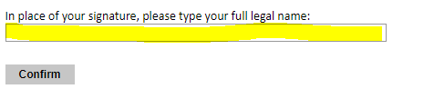
- Certify that the information you provided in the application is true and complete by typing your full legal name in the Signature Box.

REVIEW
- The application will review the responses entered and will display any incomplete questions and required attachments that are missing.
- If no errors appear, then your application is ready for submission.
- If any errors appear, correct or complete these sections and return to the Review section to determine if your application is ready for submission.
REVIEW ALL RESPONSES. CLICK SUBMIT.

CREATIVE PACKAGE AND VIDEO
- You also need to upload at the Fulbright Commission Platform <https://fulbright.com.br/candidato/net_public/?app=login> the following content in one PDF:
🎬 Attach in only one file your Creative Package;

MFA APPLICATION CHECKLIST

A COMPLETE APPLICATION FOR PLACEMENT PURPOSES CONSISTS OF THE FOLLOWING COMPONENTS:

REQUIRED ITEMS | DESCRIPTION | COMPLETED
APPLICATION | Submit your application through as outlined in these instructions and the call for applications.
ACADEMIC TRANSCRIPTS | Official copy of your bachelor’s degree transcript from your degree granting institution.
CV | In English limited to four pages: Include education; work experience and internships; honors and awards; and publications or creative works.
ESSAYS | - Study Objectives and Personal Statement. Personal Statement in English, one page. The essay should explain your education and experience, your future goals, and how you think the MFA program will help you achieve those goals.  - Study Objective in English – you must send a study objective with no more than one page.
PROPOSED U.S. INSTITUTION | You should provide up to 3 university preferences with as much information as possible. Most MFA programs, especially top-ranked ones, are extremely competitive and have rigorous and detailed application requirements. If you’re selected to the program, you must meet the requirements of the institutions, which you have been selected. Note that, due to the length of the Program, the MFA in screenwriting from Columbia University is not eligible.
ID | Upload copies of your current passport or your official ID and those of your accompanying dependents (Passport or CNH or RG). If you have already received a J-1 and/ or a J-2 visa, it is necessary to include a copy of your DS-2019 form or the visa page in the passport.
VALID SCORE REPORT (TOEFL OR IELTS) | Score report of proficiency test, taken no earlier than June 1, 2020 (102 TOEFL iBT, or 7.0 IELTS). If you intend to take a TOEFL iBT to apply, when registering for it, be sure to note that your score should be sent to the Fulbright Commission Brazil, code 7522, and to IIE, code 2326.
3 LETTERS OF RECOMMENDATION | Letters from professional and/ or academic references from instructors, professors or work supervisors who know you well. From industry professionals, teachers, mentors – ideally people who are familiar with your writing and work.
Creative Package | In English: composed by a one-page synopsis (It must last up to 500 words, which must also contain title, genre of the screenplay and a logline with no more than 70 words. It should be prepared using 12 pt font Arial, simple lines spaced. Margins 4cm.) AND the Screenplay (from five to seven pages - format: 12 pt font Courier or Courier New, simple lines spaced).

NOTE: Synopsis and Screenplay must be sent through the Fulbright Brazil Platform available at <https://fulbright.com.br/candidato/net_public/?app=login> as part of the application materials. Your Synopsis and Screenplay must NOT contain any personal information, which means candidates’ identities will be kept hidden from reviewers. It must be sent by no later than July 09, 2021.

